Installing Aftermarket fan on 68-82 Corvette

This was put on a BB 1968, manual tranny, no AC/PS, or PB's. All years from 68 to 82 should be about the same. Installing on a SB should be the same.

- Here is the part box of the stuff I ordered from summit; its Summit part prm19115, it pulls 2950cfm, the highest single fan cfm rating at only $88.95.
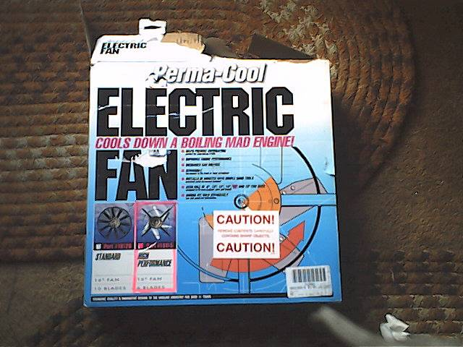

- Here is the actual pic of what it looks like: Its 16", same size as stock radiator fan on a BB. The little pack next to it has the special attachments to attach to face or radiator, and also comes with the other stuff in the other pic. The below pics come with the basic fan order, wirng, connectors, splicers, etc

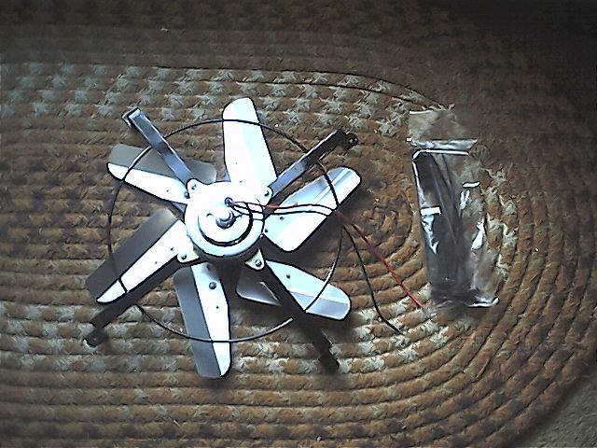

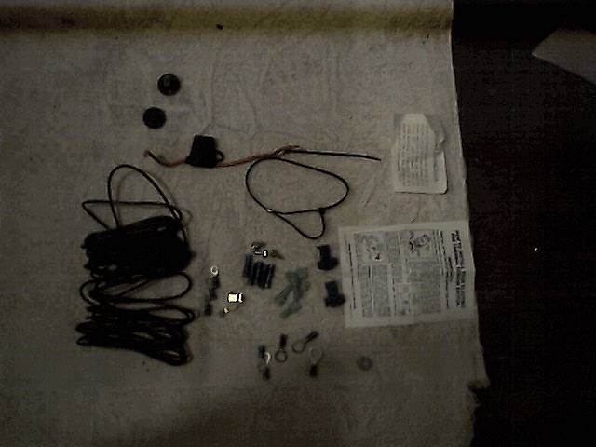

- Heres part number prm 19007, wiring and installation kit, $39.95. As you see, it comes with connectors, in line 30 amp fuse holder, and a temp switch that screws in place of the stock temp sending unit (NOTE: If you want to screw in type of switch that goes in place of the temp sendor, take the plug out of the other side of the block, and install the new swicth there. You CAN NOT run both the switch and the temp unit wire togetner on the same switch. If you dont want to mess with any type of screw in temp swicth, there is a temp switch that wire ties directly under you upper radiator hose (see Summit). I went with the screw in type.

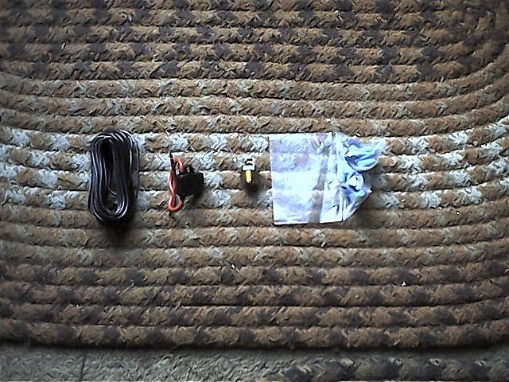

4. Pic of the start:, with all stock stuff in place

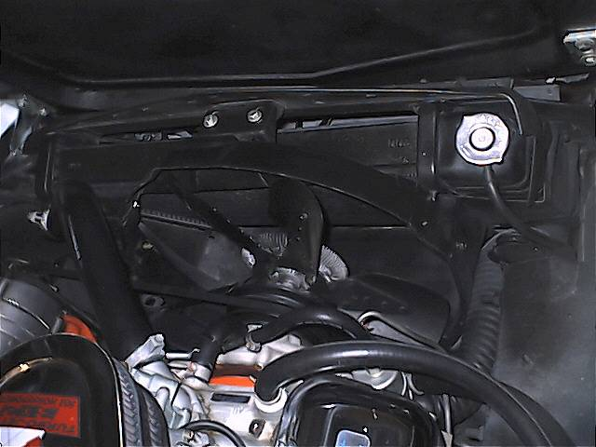

5. First, disconnect POSITIVE side of battery. Ensure engine is cold, then drain your radiator. Should be on drivers side, under radiator, little petcock. Loosen all belts at altenator, ac, etc. You DONT have to totally remove them.

6. remove upper radiator shroud: NOTE: You dont have to remove the
bottom shroud. Its a real pain in the butt, and there is NO need to.
Just remove top part of shroud. Remove stock fan. There are 4 bolts,
half inch heads. Be carefull when removing last nut. Fan is heavy, and
could fall into radiator, punching a hole in it. Fan pulley will come
off to. Heres a pic with the old removed. Note at this time, stock
fan, fan pulley, upper shroud has been removed.

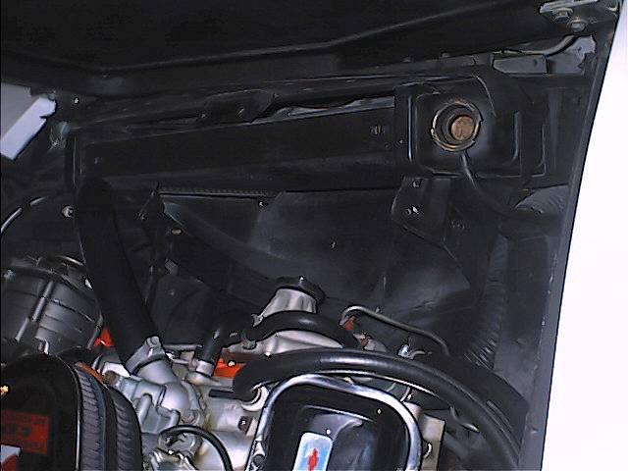

7. Install new fan. NOTE. Ensure fan is centered, not to high or
low, or to one side where it will hit the radiator shroud. This is a
two man job. The way it mounts, there are rubber pads that stick on the
new fan leg mounts. They rest against the radiator. Special wire ties
go thru the legs and pads, thru the little fin gaps, and again, rubber
pads on the other side where the wire ties tighten. READ instructions very carefully wether you have a cross or down flow radiator. (its easy, regardless). Install the fan so its a PULLER: Red wire goes ground, black goes to ignition hot (instructions are easy to read with diagram). Fuse holder goes on ground wire. Heres a pic of the fan with the wire ties, rubber pads that stick on the fan brace legs

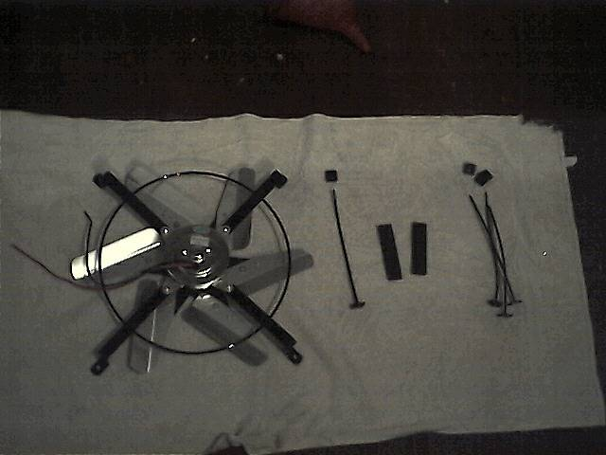

- Heres a pic of the fan installed, waiting to be wired.

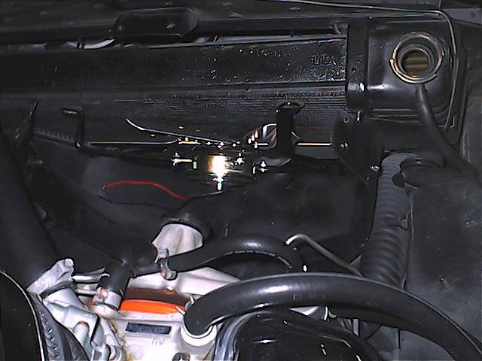

- Wiring: Easy, I went with the temp switch in the head, replacing the old temp sender unit. (I placed the old temp sending unit on the other side of the head where there is a plug, Its the same size, so the old temp sender fits. Again, to miss this step, you can get the temp swicth that fits on the radiator hood. Heres the stock temp sending unit drivers side, which I later moved to the other side of the head by lengtening the stocksending wire (passenger side).

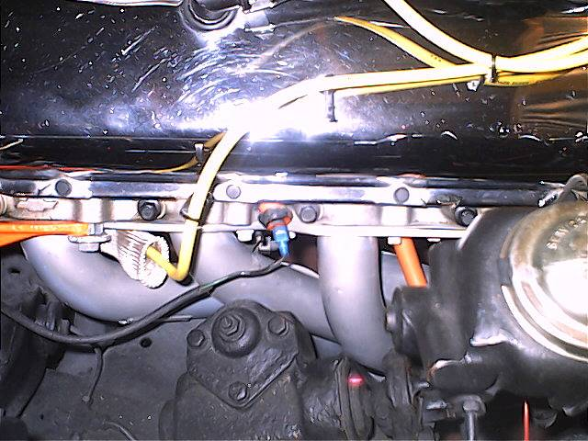

10. I left out the pic of the new temp swicth unit (which is 170 degree activated) It looks just like the stock temp sending unit, but has two prongs, which acts as a switch when temps get 170 or more

11. Now: wiring is easy: Red goes to GROUND with the supplied 30 amp
fuse in line. BLACK wire goes to the prong on the switch in head, and
form the other prong on the switch , to an ignition hot source. Its
that easy. Every nut, bolt, connector supplied.

Let me stress, the black wire goes to an IGNITION ON only source, You
dont want it running when the motor is off when you are working on it,
or it running when you start the car (that would be just extra juice
wasted to start the car)

Bolt old fan/water pump pulley back on ; NOTE: You may have to get 4,
1/2 shorter bolts to bolt the pulley back on, but the old ones will
probably work.

Tighten petcock drain (not TOO TIGHT, or youll bend the petcock valve
handle). Refill radiator: Note. After you make a couple of runs,
check level radiator level again when engine is cool It will take a
couple of times till you get it back full again

Reattach positive cable.

Tighten all belts

reaatch upper radiator shroud

Start car. Look for anti freeze leaks

Watch car as it idles, to ensure fan comes on when temps get 170. Go
for a short cruise. Come back. Let engine cool, check radiator again,
and keep doing so until you are sure its full (no air bubbles)

You can get a good temp reading ONLY once you are sure the raditor is
completely full

Here is what I noticed
My thermostat is a 160. Im running now at just about 180, compared
to about 170 with the stock fan (at stop and idle), cooler at about 170
at highway speeds

I kept my stock BB shroud

There you have it..

I wonder though why Im running slighly hotter (10 degrees)

Again, remember, you cant hook up your stock temp sending wire to the
type in block temp swicth I used. See above for how to get around it,
and still use you stock sender

