C3 odometer gear replacement done easy (no needle removing….no full dissasembly)

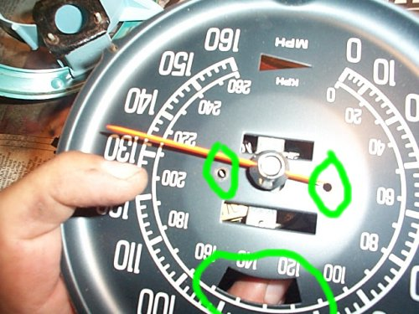

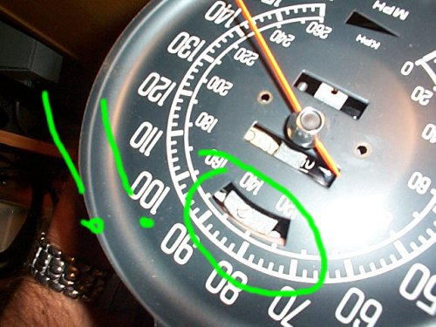

- above we see the screw locations for the 2 face plate screws… remove these first. This will then allow you to rotate the face until you can remove the 2 top assembly screws THROUGH THE “BRIGHT” opening hole as seen above.

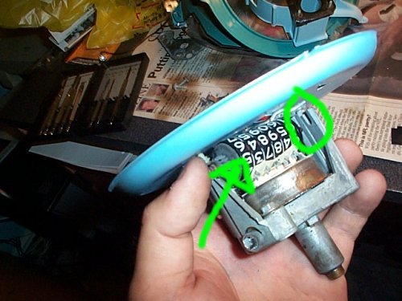

- now that you can move the top plate and the top assembly plate up a bit, you can take the black retaining clip out that is holding the MAIN odometer wheel in place. Once that is out, you can slide the wheel to the side, and remove it.

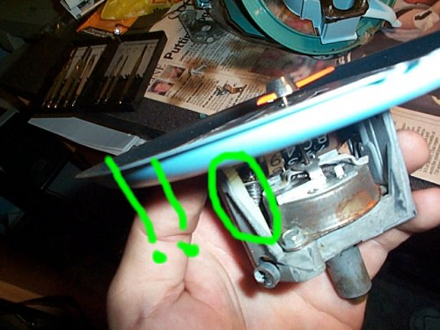

- here we now have access to the 1st white odometer gear. The top part of this white nylon gear sits in the top assembly plate that was held by the 2 screws removed through the “bright” opening in the speedometer face plate. The bottom of this gear sits in a hole in the bottom of the assembly, and is driven by the 2nd odometer drive gear under the cylindrical can (cannot yet be seen…)

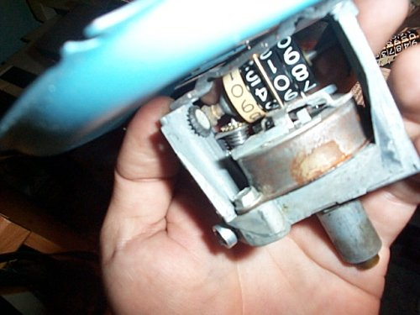

- here we have removed the 1st white odometer gear…

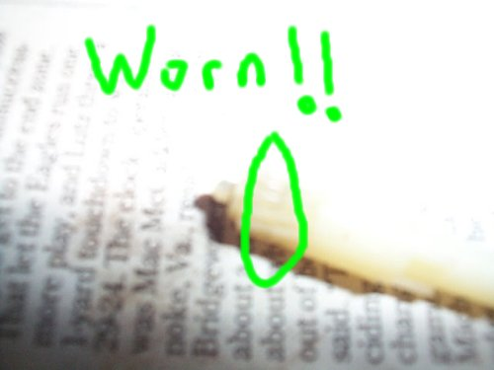

- now we examine the condition of the 1st odometer gear as seen above… this particular one had grooves it in, which necessitates replacement.

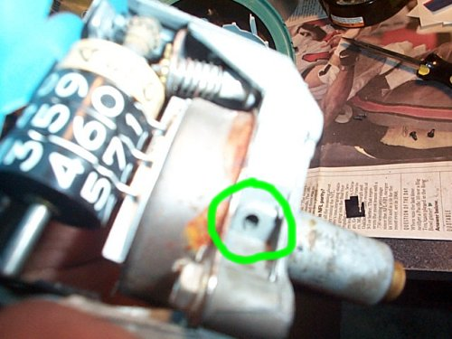

- Since pulling the dash is not an fun task, we might as well replace BOTH odometer gears while we are here….. The most common part to fail is the odometer gear in the bottom (the 2nd gear)…. It is a black nylon gear that hides under the cylindrical can. You can see the end of this gear in the hole here. The trick to getting this gear out is as follows::: (without complete disassembly….)

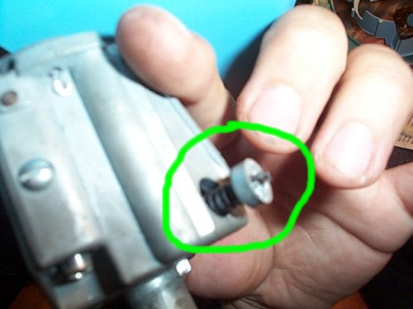

- here is the other end of the 2nd gear in the bottom of the speedo. There is a circular piece in the casting which is removable!!! So how do you remove it?

1st determine if your 2nd gear is in 1 piece… do this by turning the speedometer shaft and looking at the end of the gear as it sits in the hole…. If you notice it turning then its in 1 piece. If its not turning, it is either stripped or broken in 2.

If its in 1 piece then you can remove the bottom gear by pushing on the end of it on the hole in the picture in #6 above. It will take a bit of strength to get the circular disk to pop out like the pic above.

If it is not in 1 piece then you require a long thin hard piece of metal to drive the circular piece out from the hole in #6.

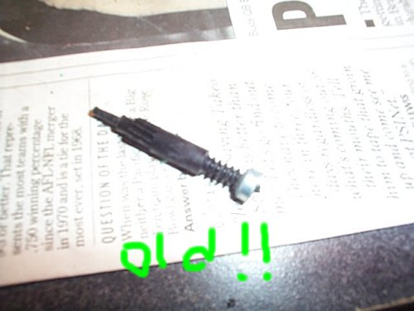

- here we see the old 2nd nylon gear as we pulled it out attached to the circular disk.

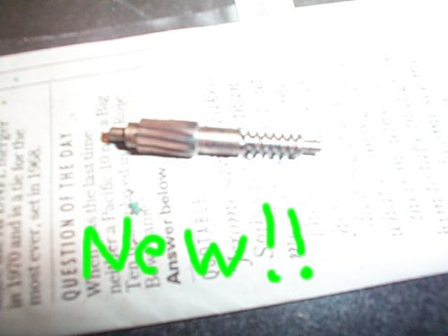

- here is the new metal gear purchased from corvette central for ~8 bux (corvette America has them cheaper I think)////// install the metal disk on it and stick it back in there!!!

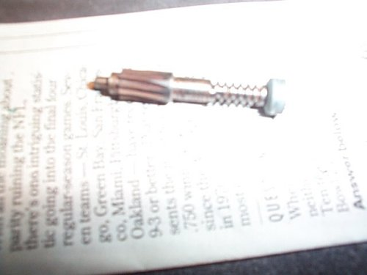

- disk installed now ready ta go..

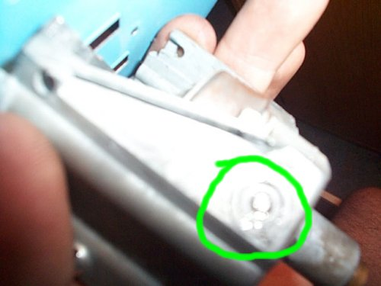

- make sure to put pressure on it, so itll seat ALL THE WAY DOWN FLUSH with the rest of the housing, otherwise the gears might not engage each other.,.

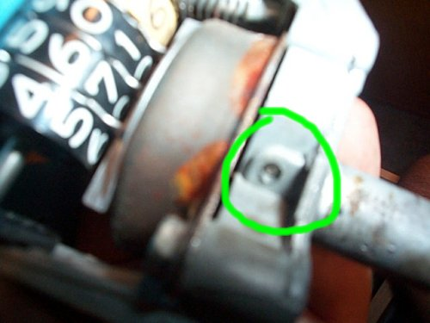

- heres just a pic of the other end…(yah make sure its in the hole on the other end LOL)

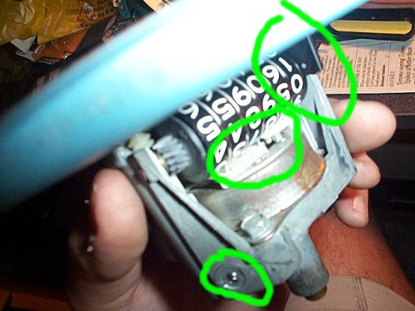

- now begins the reverse assembly!!!! Put in your NEW white nylon gear (or one that’s not stripped!!!) and push it down and look in the hole on the bottom to make sure its in all the way…..

now install the main odometer wheel back, making sure ALL the metal slots are locked in place by the long flat metal piece which holds them together… make sure u don’t break the plastic piece going around the metal tabs….

Now tighten down the top piece through the bright hole again.

Tighten down the face plate..

Put in the odometer locking tab, making sure its flat against the face of the speedo.

YOU ARE DONE!!!

Now hook a drill upto it and test it out..

Make sure u go the right way!!

