Installing a LeMans Gas Filler (similar to that used on Cobra’s and Vipers) is not difficult. The hard part is in determining the relationship of your tank filler neck mounting surface to the rear deck and gas door on your car. My installation *A* is for a 71 coupe and I also made one for a buddy *B* for his 70 coupe.

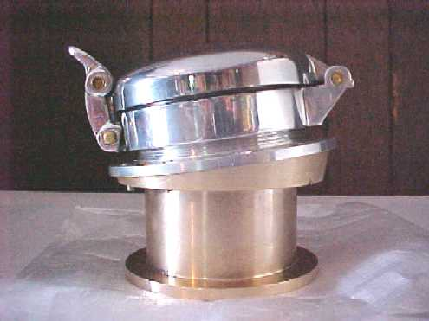
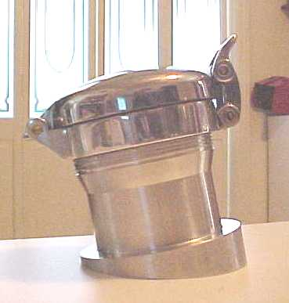

The two units required different designs due to the tank configuration being different (I suspect his was not the original tank). My goal in each case was to make the cap functional, integral to the tank (yet independent of the body) and cosmetically aligned to the body.
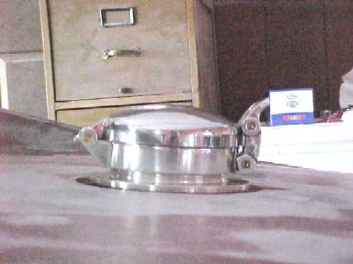

The process was as follows:

Material required:

LeMans Cap $122.00
Mounting Flange (*A* only) $ 22.00
Machined Adapter $ 94.00 (4.5” OD x 2.5” ID x 7” long aluminum stock )
Machine shop labor (varies) $120.00 (3 hours at $40/hour)
Misc. bolts and gaskets $ 8.00
Extruded Rubber or Trim Ring $ 10.00 to $20.00

Step #1:
Remove the gas filler door and trim ring. Remove the rubber spill boot from around the filler neck. . (Just a word of caution: For safety’s sake, remember that you are working with a gas tank. Also, to avoid future problems, use a shop vac to suck up any dirt, etc., to avoid foreign material from falling into the gas tank.) Remove the nine bolts holding the filler neck to the top of the tank. Lift off the filler neck and gasket.

Step #2
Determine which of the two designs best suits your application. If your mounting surface is flat (horizontal) you will need an adapter like *A* with the taper at the top. If your mounting surface is slanted, you will most likely need the one like *B* with the tapered surface at the bottom. Either way, due to differences from one car to the next, you will need to take a series of measurements as indicated in the sketches shown. I’ll be happy to help with this part if anyone wants to tackle this project.

Step #3
Get your materials

Step #4
Have adapter machined. I found it best to not have the machine shop drill the holes for bolting the adapter to the tank. As an option, you could have the machine work done, take it home for a test fit and the mark the bolt holes for the shop to drill.

Step #5
Install Cap Assembly with new bolts and gaskets.

