I own a 1973 Corvette with a 350CID engine and used this technique to simplify the installation of new spark plug wires to the four front engine cylinders (cylinders 1 & 3 on the driver’s side and 2 & 4 on the passenger side of the car). These four wires are routed through motor mounts and then metal shrouds attached to the underside of the engine.

(Supplies: electrical tape and approximately 4 feet of clothesline cord)

Follow the following steps for each wire:

- Disconnect the spark plug wire from the distributor and the spark plug. (NOTE: these pictures show the wires and cords on a table top for photo purposes only - the actual spark plug wires will be in their normal locations on the engine when you step through this procedure)
- Remove the rubber boot from the distributor end of the wire.
- Insert one end of the clothesline cord into the metal connector at the distributor side of the wire. 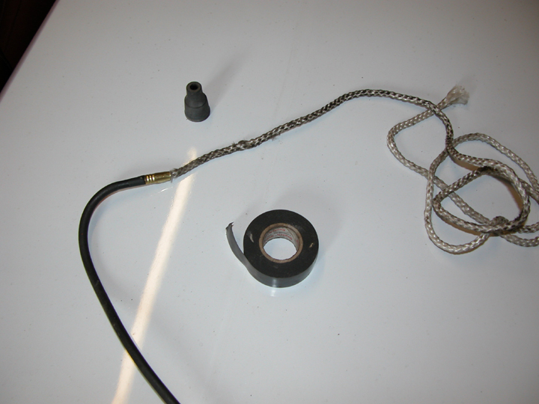
- Wrap the wire/connector/cord with the electrical tape so that it is secure but not bulky. You now have one continuous cord/wire that is unobstructed at the distributor end and runs through the metal shroud and engine mount.

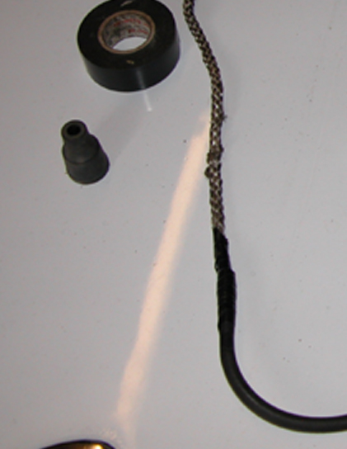
- Gently pull on the spark plug end of this cord/wire and help feed the other end (may require some back and forth motion if the line binds somewhere) until the spark plug wire is completely through and free of the shroud/motor mounts. The other end of the cord should still be seen at the distributor end.
- Unwrap the electrical tape, remove the old spark plug wire, replace it with a new spark plug wire, insert the clothesline cord back into the connector, and rewrap the connection with the electrical tape.
- You now have one continuous cord/wire (AGAIN) that is unobstructed at the distributor end and runs through the metal shroud and engine mount.
- Gently pull on the distributor end of this cord/wire and help feed the other end (may require some back and forth motion if the line binds somewhere) until the new spark plug wire is completely through the shroud/motor mounts.
- Unwrap the electrical tape, place the rubber boot on the distributor end of the wire and connect it to the distributor - and connect the other end to the spark plug.

This technical tip is based upon my experience rewiring older homes. The basic concept is to snake a metal tape through the wall (or take advantage of an existing old wire) so that it is routed through the space where a new electrical wire is desired. Attach a new Romex electrical wire to the end of the tape (or old wire) and pull the tape (or old wire) with the new Romex wire back through the wall – remove the tape (or old wire) from the new Romex wire and you have the upgraded service desired.

