INSTALLING A REAR MONOLEAF SPRING

This was done on a 1981 ‘vette, though I’m sure it can be applied to most any C3.

First, make sure all the parts are included with the kit. (My kit was a TRW spring from Van Steel)

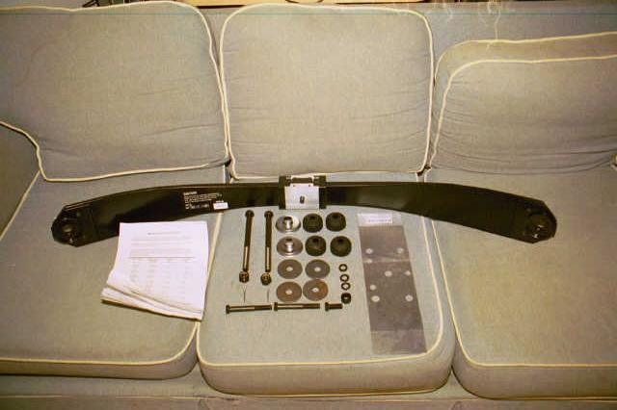

First, you want to raise the rear end of your car. If you have the old spring still on the car, this is fairly easy as a jack should fit under the car without much problem. However, my spring broke, making the car too low for the jack to fit under.

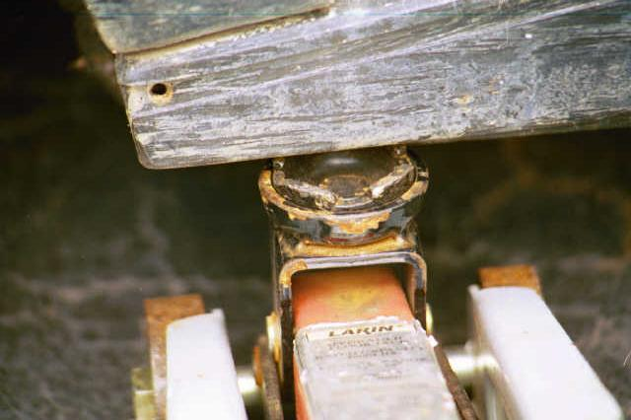

So, an easy way to fix this problem is to drive the rear of the car up on ramps. Then, jack up the car just a little bit (only an inch or so is required). Once the car is jacked up enough, you can take off all the lug nuts and angle the tire out. You may need to lift the tire up slightly, but without the spring in place, this is easy to do.
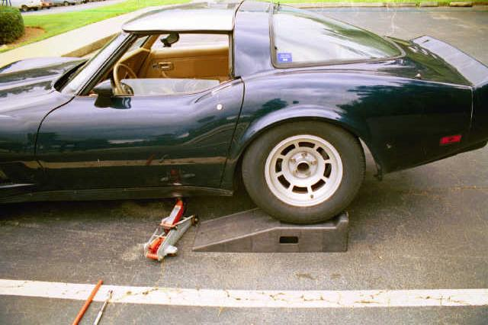
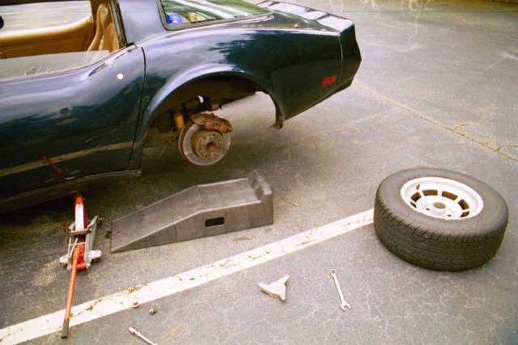

Now once both the tires are off, the axels will sag to the full extent of their travel. It is at this point that you would need to remove the old spring if you haven’t already. Unfortunately I do not have pictures of this process, but it is very easy. Start with the parts of the spring that connect to the wheel, supporting whatever end you’re working on with a jack. Take out the bolt, lower the jack, go to the other side, and repeat the process. Then go to the middle of the spring. Once the spring is off, you can start putting the new one on. Start by attaching the middle.
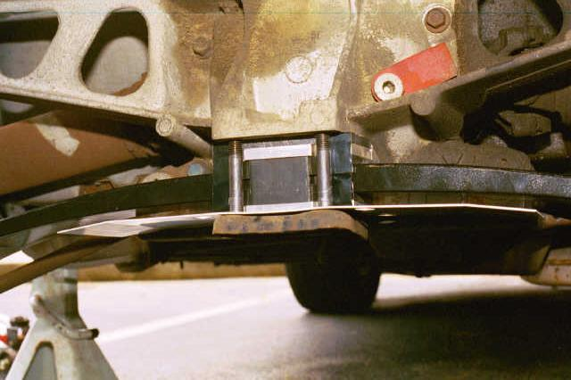
Fortunately, the new spring is rather light and I was able to support the spring, heatshield, and the spring retainer (the rusty-colored thing at the very bottom) with one hand while I hand-tightened the bolts with the other. However if you need additional support, a jack would work fine. The bolts were approximately 18mm, I say approximately because I do not have a complete tool set, however that sized socket fit rather snugly. There are two longer bolts, and one shorter one. As seen, the two longer bolts attach towards the rear of the car, while the shorter one with a spacer attaches toward the front.You want to make sure there’s enough space between the spring and the heat shield.

Now, you can move along to the outer edges of the spring.
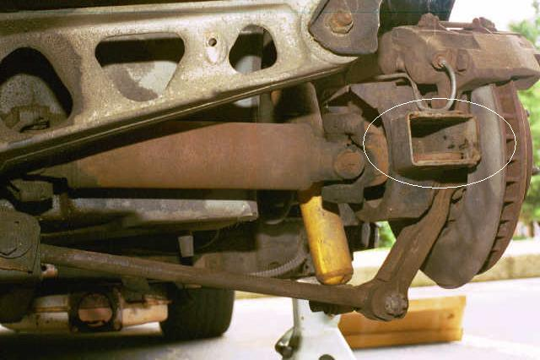
The white circle shows where the bolt will go through. Inside the box on my car was the little cup you see there, slightly rusted in color. It’s the cushion retainer. The kit came supplied with new ones, though the one on my car couldn’t come out, so I didn’t need to use that part. You may or may not need to use the one supplied with your kit. The spring cushion goes on first, then the washer on top of that, THEN put the bolt through. The bolt would rip through the cushion rather quickly without the washer in place, so it’s very important to not forget about that.

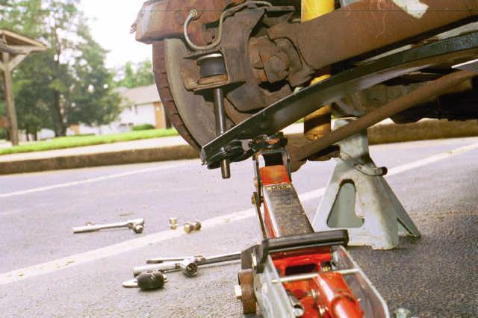
This shows the bolt in place. To be able to attach the locking nut, you will need to jack up the spring. The very edge of the spring is wrapped in metal, and the metal has a little lip at the edge that a jack fits rather nicely into. The angle of the bolt may seem a bit odd at this point. So odd, in fact, that you can’t put a wrench on the other end of it to hold the bolt into place. This is caused by the suspension being at the full extent of it’s travel while the spring is not, which wouldn’t happen under normal driving. If you find that you cannot get a wrench onto the bolt to hold it, put the nut on as far as you can get it before you just start turning the bolt. Also note that again, you’ll need to put the cushion on, then the washer, and then the bolt. Once the spring moves down, you should be able to get a wrench in to hold the bolt. Tighten the nut until you can just get the cotter pin in place.

Here, the nut is attached and the cotter pin in place.
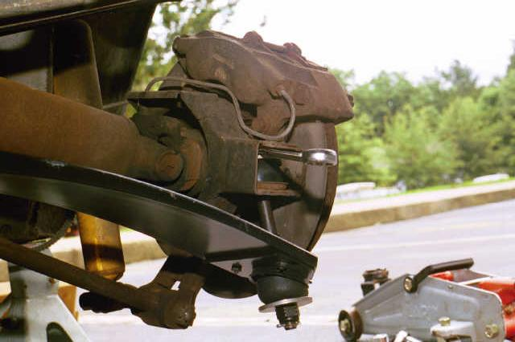
After you’ve finished one side, move on to the other. Once both sides are done, put the tires back on and lower the car. You may be in for a bit of a surprise though…

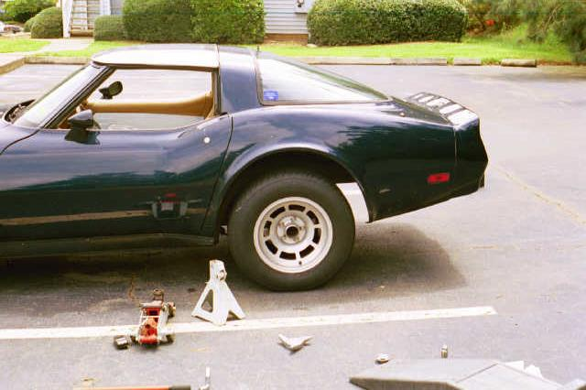
My car now sits a LOT higher in the back with the new spring. I believe this is likely due to the fact that the spring is probably rated higher than the stock one, and in fact there was a visable difference in the thickness of the spring. If this happens to you, the only way to fix the problem is to buy longer bolts. If you do, MAKE SURE you get automotive quality grade-8 bolts, and be sure you find some way to keep the nut from backing off.

Overall this is a VERY easy job to do. Installation of the new spring from start (gathering tools, etc.) to finish (clean-up) took about an hour, and this was with me taking pictures of the progress and breaking the lug wrench. The most difficult part of the job will most likely be removing the old spring, as rust can easily fuse old bolts together. Shots of penetrating oil will help, but it still might take a good bit of tugging.

