Griffin Generic Radiator and Dual Fan Install in 1971 Corvette
By 71roadster, a.k.a. Chris Cherrison
Because of the high cost ($500+) of a corvette specific radiator, I decided to go with a generic Griffin 19” X 31” aluminum radiator from Summit Racing for $180 (thanks to those who went before me and provided me with advice and answers on the Corvette Forum www.corvetteforum.com ). It is a two core radiator with 2 rows of one inch tubing. There is another Griffin with 1.25” tubing for $280, but I didn’t think the extra diameter was going to be necessary. [side note on cores: I have read that a 4 or 5 core radiator is actually less efficient than a 2 core because the more tubes you have running through the cooling fins, the less contact there is between the tubes and the cooling fins, which is what provides the heat transfer].

There was more to this project than just going to a larger radiator. My original core support was badly rusted so I had to buy a “new” core support from a junkyard. I got one that fit the wider radiator for $125 and spent another $80 to have it powder coated. I also wanted to go to electric fans for a couple of reasons; ‘trick’ factor, less clutter, less horsepower drain on the engine, and they would make room for the A-arm cross brace. Instead of buying the dual Spal fan, which is probably the best on the market and probably fits perfectly, though expensive at $400 to $500, I bought a dual fan setup out of a 1996 Camaro Z28. I got mine for $70 but the going price seems to be about $85. I cruised the f-body forums and emailed all the ‘parting out’ ad’s about the fans and got a couple of replies. The fans fit the radiator like they where made for it and only required a little trimming with a dremel tool (a VERY useful tool when working on old cars). Squeezing the fans between the A-arms required a little more trimming but it can’t be seen from above and it doesn’t interfere at all with the cooling ability or structural integrity of the fans. Tubular A-arms would probably reduce the need for trimming but will not eliminate it. The last point to the project was to clean up the front of the engine compartment. The starting point can be seen in figure 1. It is not pretty! It cleans up fairly easy with Gunk, thinner, rags, and a wire brush mounted in an electric drill (figure 2). I did a final cleaning with Simple Green and a tooth brush or rag followed with a water rinse (squirt bottles are handy and make a lot less mess than a hose). You can see the yellowing of the water pump from the clear coat I sprayed on it before I originally installed it. It was not a hi-temp clear coat and the heat finally yellowed it. I stripped it off and left it bare, though VHT does make a hi-temp clear coat. Carb cleaner works great for getting spots out of cast aluminum.
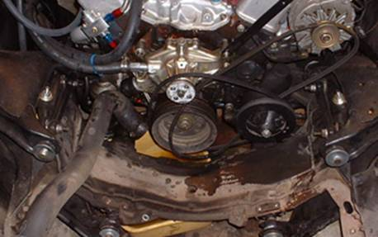
figure 1
A not so unusual problem on Corvettes is tearing and breaking of the welds around highly stressed suspension points. In figure 3 you can see where a repair was made to the front of the crossmember on the passenger side. It looks pretty beefy so hopefully it won’t happen again. If you are cleaning up any part of your frame you want to keep a sharp eye out for cracked welds or torn steel. It HAS to be fixed IMMEDIATELY as it could be a matter of life and death to you, your passengers, and your car!
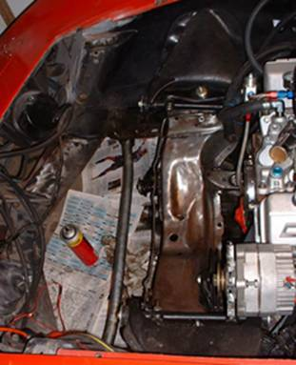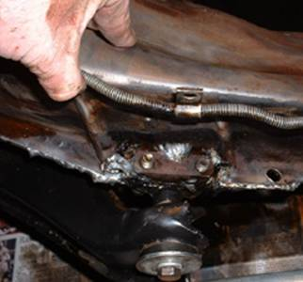
figure 2 figure 3

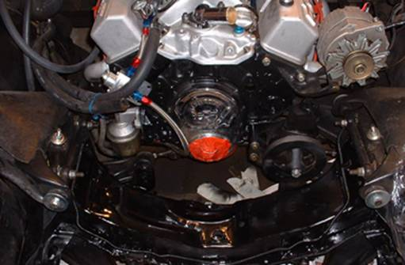
figure 4

Because it’s satin black (VHT self priming epoxy works far better than Rustoleum or Krylon, has rust inhibitors, and is SUPER tough) it’s hard to see, but it cleans up real nice (figure 4 and 5). I used Saran wrap to cover any hoses and wiring I didn’t want painted and I taped around the intake and valve covers with masking tape and newspaper (that’s a factory alternator mount out of a 72 or later Vette if you are wondering). I cleaned from the front of the engine forward, but that is just me! Can’t stand to see dirty grimy rusty parts in my car, so while the hood is off…GO TO TOWN!

Finally putting things back together (figure 6). I think the aluminum pulleys just look SO cool. I bought these at a local car show but they can be had from Summit, Kragen’s, e-Bay, where ever. It’s hard to tell, but I also replaced the chrome timing chain cover with an aluminum one from Summit. Get the unbranded model for less money because the water pump will cover it up anyways. I also installed a Fluidamper harmonic balancer from Summit. It comes unpainted and looks polished, but needs to be painted to prevent rust. I used VHT high temp clear after highlighting the numbers and hash marks with white paint. It matches the pulleys perfectly.

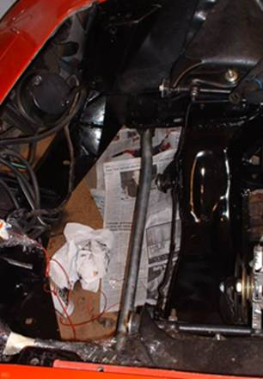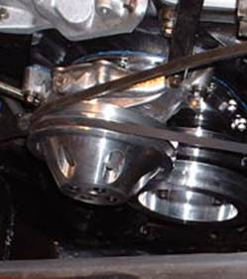
figure 5 figure 6

In figures 7 and 8 you can make out the ‘L’ aluminum I used to make the lower bracket for the fan shroud. It only cost a couple of dollars and works beautifully. In figures 9 and 10 you can make out the upper brackets I made out of 1” x .25” strap aluminum. A hammer, saw, vice, and drill was all it took to make these. I installed heli-coils in the mounting holes to ensure the stay mounted to the core support. And I polished them with a buffing wheel mounted to my bench grinder. I also polished the radiator. It’s easy to do and looks so much better than the raw anodized aluminum (check sears for cheap polishing kits). I used a wire wheel to strip the anodize off the aluminum where necessary. Of course it’s more to clean, but…oh well! It looks great! I used simple ‘through the radiator’ type tie-wraps for securing the upper part of the shroud to the radiator ($5 from summit). In these pictures you can also make out the A-arm cross brace. It BARELY fits behind the fan. I will probably have some beefier mounting brackets made on the next trip to the welders. It’s hard to see, but the radiator hoses fit PERFECTLY! I bought them at Autozone (Autozone part numbers 238 and XL060). I don’t know the original application (Autozone’s computers couldn’t back trace from the part numbers) for these hoses but they fit this radiator like they were made for it. I cut a couple of inches off of the top hose and about a half inch off the bottom hose. Test fit yours before you trim them though.
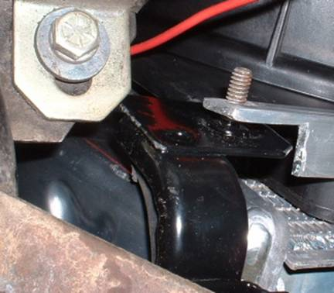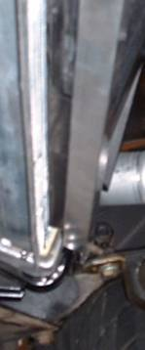
figure 7 figure 8
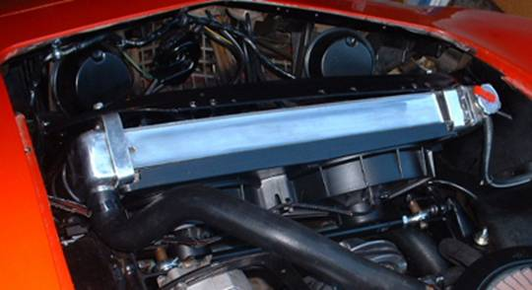
figure 9

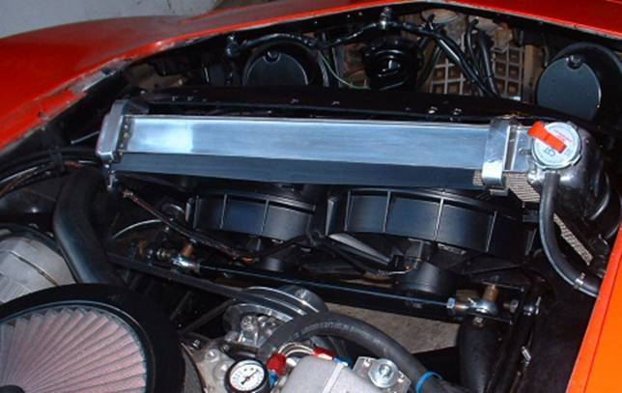
figure 10

The last part of this project involved the wiring for the fans. I got some connectors and wires for the fans from the junk yard and I bought the Painless fan wiring kit form Summit. It uses a water submerged thermostat that provides a ground as it gets hotter. It turns the fan on at 180 degrees and shuts them off at 165. It was a HUGE pain to get the plug out of the passenger head (I had to partially remove the header to get a good grip on the plug, otherwise I was just rounding it off and would have made a LOT more work for myself), but the thermostat won’t fit in the manifold plug because the thermostat housing is in the way, and beside, it looks much cleaner with it out of the way in the passenger head. The Painless kit is fairly straight forward but you have to run some wiring and find a place to mount the relay and circuit breaker. I made this relay/power distribution panel (figure 11) and mounted it to the fender will next to the alternator. I don’t drive in the rain so I am not worried about it getting wet, but I will probably move it to the backside of the drivers fenderwell when I finally pull the engine and then there won’t be any concern of it getting wet. The nice thing about this is it provides a point to get battery power, ignition switched power, and whatever else you want for the next install. I also mounted a relay to run my 130 watt high beam headlights, which draw too much current for the factory wiring to handle. I ran the fat red wire to the starter (which is connected to the battery) and there is a fat ground wire running to the frame. The circuit breaker that comes with the kit is rated at 30 amps and didn’t pop with both fans running so I know the fans draw less than 15 amps each, and they cool the engine fast enough that they are only on a minute at a time. I may have to upgrade the alternator to a high output unit after testing with the stereo, hi beams, heater fan, etc.

Overall, I am VERY happy with this install. Although it was a lot of work and was still fairly expensive, it was FAR cheaper than going with a made to fit radiator and fans, and in my opinion it looks like it was made for the car. If you are just doing a fan install, the f-body fans are the perfect budget solution. The fans are quiet enough that I can’t hear them, although my car does have a fairly rumpy idle. A last point of concern is the radiator cap on the radiator. Since the Corvette has an external tank with it’s own cap, the one on the radiator is redundant, and it may interfere with the hood (I did a test fit and it clears by at least a quarter inch). I will probably cut it off and use Aluma-weld and a small piece of sheet aluminum to seal the hole. Aluma-weld is an aluminum solder that can be used with a propane torch. I will at the same time move the overflow tube onto the side tank and then the radiator will be almost exactly like a factory radiator, at least it will work similarly with the external tank. The Aluma-weld is really easy to use, polishes nicely, and is available at some hardware stores. I will update the article later with that mod and any updates on driving with the new fans in hi temp situations.

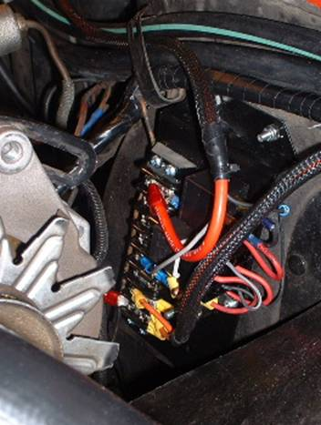
figure 11
If you have any question or comments, feel free to post them on the C3 forum at www.corvetteforum.com. Or you can get my email address off of the forum and email directly.

